Academic Health Science Network case study template (including guidance for completing / submitting)

Case study name: Teleswallowing –using telemedicine to remotely assess patients’ ability to swallow safely.

AHSN /S involved: Innovation Agency

Images:

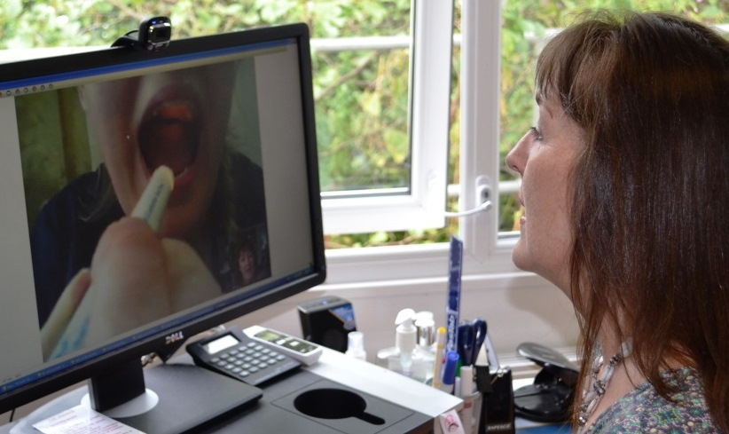
Multimedia: video link https://youtu.be/LydPsPyBOBk

Overview summary (200 words maximum)

Teleswallowing is an innovative use of telemedicine enabling a speech and language therapist to rapidly and accurately, remotely assess a care home resident’s ability to swallow, without the need for face-to-face assessment.
Since it was established in 2012, Teleswallowing has demonstrated cost efficiencies and improved recovery outcomes through reductions in waiting times - which could otherwise be more than 10 weeks; a reduction in unplanned hospital admissions; and improved quality of life for patients in a vulnerable age group diagnosed with swallowing difficulties (dysphagia). It has been adopted by two NHS trusts with more requesting presentations.
Teleswallowing was successfully piloted and adopted by Blackpool Teaching Hospitals NHS Foundation Trust speech and language department and has been rolled out to more than 15 North West care homes. Through support from the Innovation Agency, Teleswallowing has been developed in five nursing homes in Cheshire; and training is under way in 147 care homes in the Fylde Coast Vanguard programme.
Created by two clinicians – Veronica Southern, Clinical Lead for Telesolutions at Blackpool Teaching Hospitals NHS Foundation Trust and Dr Elizabeth Boaden, Clinical Lead for dysphagia at a Cheshire NHS Trust – Teleswallowing Limited aims to have a European reach by 2018.

Challenge/problem identified (150 words maximum)

- Swallowing difficulties (dysphagia) may precipitate aspiration pneumonia, malnutrition, increased length of hospital stay and a reduction in quality of life.
- National Clinical Guidelines support early identification, assessment and management of dysphagia to facilitate better patient outcomes, reduce mortality rates and long-term costs.
- Delays in the assessment of dysphagia due to waiting lists can cause deterioration of health.
- Hospital admission can be avoided if dysphagia is assessed and managed at the point of need.
- Dysphagia is prevalent among the elderly. There are 426,000 elderly and disabled people in residential care: between 50-75 per cent of nursing home residents have dysphagia.
- Assessment of care home residents’ swallowing by a speech and language therapist requires outpatient appointments or care home visits.
- Attendance at outpatient clinics requires carer supervision, hospital transport, inconvenience and stress for elderly patients.
- Care home visits by a speech and language therapist are an inefficient use of NHS time and resources.

Actions taken (150 words maximum

The Innovation Agency awarded a grant to Teleswallowing Ltd through its Innovations with Impact fund, which enabled the service to be delivered in five nursing homes in Cheshire.

The Innovation Agency’s commercial team’s support has helped Teleswallowing secure business contracts with Blackpool Teaching Hospitals NHS Foundation Trust and establish an out of hours trial service at the trust. The evidence from this work will help spread the innovation in the wider NHS.

Teleswallowing is also in talks with Royal Liverpool and Broadgreen University Hospitals NHS Trust.

The support from the Innovation Agency is part of a European Regional Development Fund programme of business support delivered by a dedicated commercial team, focussed on connecting the NHS with local SMEs with innovations which can improve health care.

Impacts / outcomes (300 words maximum)

Result of the pilot at Blackpool Teaching Hospitals University Trust (August 2013 – March 2014) Pilot scheme involved three nursing homes and 12 patients with dysphagia
- 100% diagnostic accuracy for diet and fluid modification compared to bedside assessment
- 79% reduction in cost per patient compared to home visits
- 98% reduction in cost per patient where early assessment and treatment provided by Teleswallowing prevents deterioration in patient health and subsequent admittance to hospital
- 66% reduction in time taken to assess each patient compared to home visits
- 50% reduction in time taken to assess each patient compared to bedside assessment in hospital
- Improved response time to referrals
- Improved quality of service for patients and care homes
- Increased care home staff knowledge and awareness of dysphagia improved their early identification of dysphagia symptoms

Stakeholder benefits:
- Patients benefit from faster assessment in the comfort and convenience of their residential surroundings
- Care homes can demonstrate that they are providing state of the art technology in the care of their residents and more highly-trained staff
- Speech and language departments benefit from long term time savings/reduction in time wasted
- Clinical Commissioning Groups (CCGs) benefit from long term cost savings

Partnerships:
- Working with a dedicated commercial programme manager from the Innovation Agency, Teleswallowing Limited is in talks with hospital trusts in Liverpool and is trialling a unique out of hours Teleswallowing stroke service in Blackpool Teaching Hospitals NHS Foundation Trust.
- Through the partnership with the Innovation Agency, Teleswallowing Limited has secured EU Innovation Twinning funding with a Cologne-based innovation team with the aim of sharing the service throughout Germany

Awards
- To date, Teleswallowing has been recognised locally and nationally in IT Innovation Programme awards, two NHS England Regional Innovation awards and the North West Coast Research and Innovation Awards
- In addition, Veronica Southern has received awards: 2015-16 NHS England Challenge Prize in Rehabilitation (Highly Commended) and NW Informatics Skills Network Clinician in Informatics 2016

Supporting quotes from a stakeholder / partner or service user (50 words per quote maximum)

“Working closely with the Innovation Agency has provided another dimension to Teleswallowing: they bring the business acumen and maximise the project’s potential to a wider healthcare audience. We are the clinicians, they are the business brains and the combined expertise is ideal for success.
“The commercial team of the Innovation Agency were instrumental in us securing contracts with two major NHS hospital trusts.”
Veronica Southern, Director and co-founder of Teleswallowing

“Teleswallowing is a fast, efficient service which reduces the risk of chest infection or dehydration, reduces waiting time and benefits patients. It provides quick access to a service that’s needed. A six week wait for this type of service can mean the difference between life and death. In addition, not going to hospital is better for the patient and saves the NHS in terms of costs, pressure and bed space.”
Paula Bell, Owner, Belsfield Care Home
Patient impact (for internal use – this will not appear on Atlas)

Positive impact on patients: their physical and mental wellbeing, reduction in waiting times.
Paula Bell (Tel:01253 777467), owner of the Belsfield Care Home group, would be willing to speak about Teleswallowing (positive impact on patients, plus benefits to care home staff)

Plans for the future (100 words maximum)

- The aim is to roll-out the Teleswallowing service to the North West region and beyond by 2018
- The out of hours Teleswallowing service with Blackpool Teaching Hospitals NHS Foundation Trust runs from May 2017 to June 2017
- Teleswallowing Limited has contracts with NHS England New Care Models Programme/Blackpool CCG/Wyre and Fylde CCG and aims to be supporting 146 homes/hospital trusts in the next three months
- Sustainability - with the increase in the use of digital solutions within the NHS, Teleswallowing should become an embedded service delivery model within the next 24 months.

Which national clinical or policy priorities does this example address?

- Care and Quality
- Funding and Efficiency
- Health and Well Being
- Driving Economic Growth
- Long-term Conditions and Dementia Care

Start and end dates:

Teleswallowing was trialled in 2012. Teleswallowing Limited was created in 2014. This is an ongoing project.

Impact for Innovation funded roll-out to Cheshire nursing homes: March- September 2016

The out of hours Teleswallowing service with Blackpool Teaching Hospitals NHS Foundation Trust runs from May 2017 to June 2017

Project contact for further information  Veronica Southern MA BSc MRCSLT  Director  Teleswallowing Limited  Email: veronica.southern@hotmail.co.uk  Tel: 01253 395187  Mobile: 07941 373 118  www.teleswallowing.com | Media contact for further information  Caroline Kenyon  Director of Communications and Engagement  Innovation Agency  Tel: 01772 520280  Mobile: 07950 866394  www.innovationagencynwc.nhs.uk

