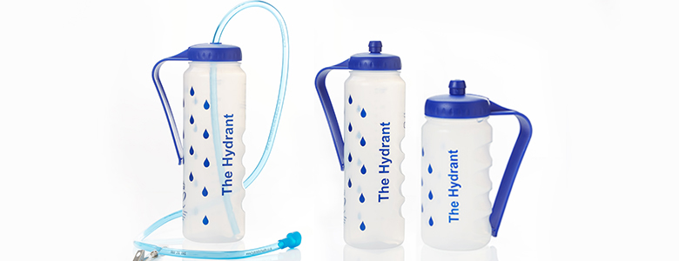

Innovation Exchange
Hydrate for Health – The Hydrant

Hydrant Service Users & Carers Views from Warrington, St Helens, Widnes, Halton, Manchester, Prescot and Wigan
“Found the hydrant very useful, I was able to get a drink without my carer being there”.

“It has helped me out a lot, and it helps my son as he feels less worried when he goes to bed. I now have something to drink without getting out of bed, and disturbing him”.

“After a bad seizure all my muscle control is lost, we hooked the hydrant up and this enabled me to drink from the straw tube as needed”.

“I use this aid because of restricted movement in arms and shoulder, the long tube is a great idea. The hydrant is a really great idea!”

This feedback is from a lady and her husband who were visited and who used the hydrant bottle. The lady is a wheelchair user and hasn’t got very good dexterity. The lady liked the hydrant bottle as she could slip her hand around the bottle rather than holding it and she is able to clip the bottle to her wheelchair, and use the bottle with ease.
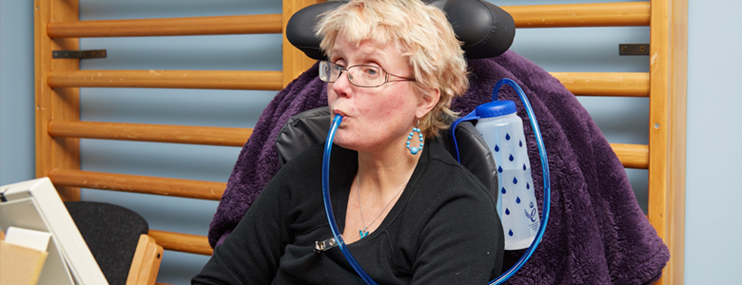
In addition, her husband also benefited as he said he had the first decent night sleep for years, without being disturbed by his wife needing a drink in the night. The lady used the tube in the Hydrant bottle throughout the night and found this to be very beneficial.

