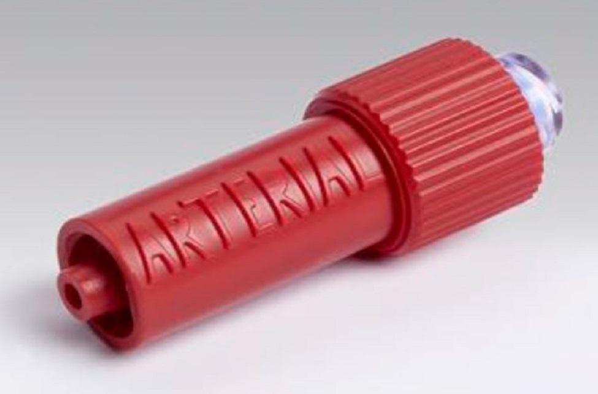
We have received excellent patient feedback for the NIC, where 100% of patient’s surveyed strongly agreed that the NIC should be used in ICUs and operating theatres for their benefit and that of their family.

Innovation Exchange
Patient Feedback
Connected Health Cities
Non Injectable Connector
Patient feedback:
“Excellent idea, feel confident this would benefit my family, myself and the NHS”

“Not using this device would seem like folly.”

“NIC is highly innovative of 1st stage design to alleviate costs to problems caused commonly in ICU situation and which improves patient quality of care”

“A wonderful idea that removes all the risk of injecting into an arterial line”

“Making mistakes impossible keeps people alive and reduces cost per episode”

