Atrial fibrillation prevalence estimates in South East Coast:

Application of recent population estimates of AF in Sweden

About Public Health England

Public Health England exists to protect and improve the nation's health and wellbeing, and reduce health inequalities. It does this through world-class science, knowledge and intelligence, advocacy, partnerships and the delivery of specialist public health services. PHE is an operationally autonomous executive agency of the Department of Health.

Public Health England  
Wellington House

133-155 Waterloo Road  
London SE1 8UG  
Tel: 020 7654 8000  
[www.gov.uk/phe](http://www.gov.uk/phe)   
Twitter: [@PHE_uk](https://twitter.com/PHE_uk)

Facebook: [www.facebook.com/PublicHealthEngland](http://www.facebook.com/PublicHealthEngland)

Prepared by: Athena Chown  
For queries relating to this document, please contact: [Athena.chown@phe.gov.uk](mailto:Athena.chown@phe.gov.uk)

© Crown copyright 2014  
You may re-use this information (excluding logos) free of charge in any format or medium, under the terms of the Open Government Licence v2.0. To view this licence, visit [OGL](https://www.nationalarchives.gov.uk/doc/open-government-licence/version/2/) or email [psi@nationalarchives.gsi.gov.uk](mailto:psi@nationalarchives.gsi.gov.uk). Where we have identified any third party copyright information you will need to obtain permission from the copyright holders concerned.

Published July 2015

Background

Atrial fibrillation (AF) prevalence estimates have been

Key Information

It is estimated that in the South East Coast 126,659 people have AF. This equates to 2.7% of the population.

AF prevalence is higher in men than women, 3.1% versus 2.3%.

AF prevalence increases with age; 2.4% of the total estimated AF in South East Coast is likely to occur in people aged under 45, 15.3% in people aged 45-65 and 82.3% in people aged over 65.

At CCG level, in the South East Coast, estimated AF prevalence ranges from 2.0% in NHS Brighton & Hove and NHS Crawley to 3.6% in NHS Eastbourne, Halisham & Seaford. At GP level estimated AF prevalence ranges from 0.1% to 6.3%.

Undiagnosed AF prevalence was lowest NHS Brighton & Hove at 1.2% and highest in NHS Dartford, Gravesham & Swanley at 2.2%.

Comparisons with the 2013/14 Quality and Outcomes Framework suggest that 65% of people with AF are recorded on AF registers.

Across the South East Coast it is estimated that 40,647 people are living with undiagnosed and untreated AF.

calculated on a whole population basis in England

using latest know age and sex distributions of AF

diagnosed in a Swedish region.

The estimates show the estimated population

prevalence of AF assuming that the population

structure of a given area is the same as that of the

reference population.

The estimates were developed using data from the

Health and Social Care Information Centre using the

population estimates and diagnosed prevalence of AF

in 2013/14. The estimates have been calculated using

age-sex specific prevalence rates from a reference

population which have been applied to each local

population. AF is often asymptomatic and there are

currently no reliable estimates of undiagnosed AF in

England.

Full details of the method and data sources used to

calculate the estimates can be found in the ‘Technical

document’ on the ‘National cardiovascular intelligence

network’ (NCVIN) website.

AF estimates have been produced for General

Practice (GP), clinical commissioning group (CCG)

and for the whole of England. The estimates are

available for download at: [www.ncvin.org.uk](http://www.ncvin.org.uk)

Current prevalence of AF in the South

East Coast

It is estimated that 126,659 people are living with AF

in the South East Coast. This means current

prevalence is around 2.7%.

There are approximately 86,012 people living with

diagnosed AF in the South East Coast. This

equates to a prevalence rate of 1.8% across the South

East Coast. This suggests that 40,647 people are living

with undiagnosed AF across the South East Coast.

AF prevalence in the South East Coast is higher in males than females, at 72,000 versus 54,000. The estimates reported here show the overall burden of AF increases with age.

The highest number of estimated cases of AF in males occurs in 75-79 age group; for females, the peak in numbers occurs in the 80-84 age group. Very few cases of AF are estimated to occur in males aged 95+ compared to females, reflecting the expected life expectancy advantage in females.

**Figure 1. Summary of estimated atrial fibrillation prevalence in South East Coast, 2014**

Estimated number of AF prevalence

Age

At CCG level, AF prevalence ranges

**Map 1. Map of estimated AF prevalence, 2013/14**

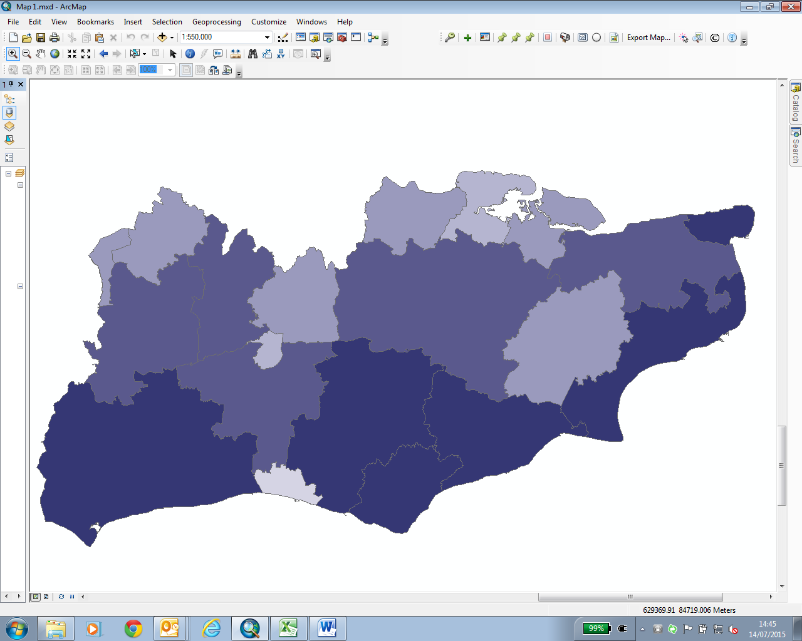from 2.0% to 3.6%.

CCGs with the lowest estimated

prevalence of AF were NHS Brighton

& Hove and NHS Crawley (Table 1.)

The CCG with the highest estimated

prevalence was NHS Eastbourne,

Hailsham & Seaford.

The quintiles of estimated prevalence

are shown in Map 1, with the highest

prevalence predominately along the

coast line. The estimated prevalence

largely reflects the age structure of

the population, with AF highest in the

CCGs that have high proportions of

elderly people.

**Table 1. Estimated AF prevalence in South East Coast CCGs**

Comparison against Quality Outcomes Framework estimates

Comparisons between the new estimates presented here and the 2013/14 Quality and Outcomes Framework (QOF) suggest that 65% of people who have AF are included on the AF registers. An estimated 40,647 people in the South East Coast may have undiagnosed AF.

The ratio of observed prevalence divided by the estimated prevalence was calculated (Map 2) to highlight the greatest disparity between observed and estimated AF.

A higher ratio indicates that estimated and observed rates are similar, suggesting a low rate of undiagnosed AF. A low ratio indicates a large difference between observed and estimated AF suggesting a high rate of undiagnosed AF.

Using the same deciles which were used for the England comparison document (available on the NCVIN website) most areas in the South East Coast are shaded in ‘best ratio’ or ‘better ratio’ indicating they have a low prevalence of undiagnosed AF compared to the rest of England. NHS Surrey Heath had a ratio of 0.58 putting it in the ‘lowest ratio’ category and indicating that it may have a high rate of undiagnosed AF.

**Map 2. Ratio of Quality Outcomes Framework recorded AF prevalence to estimated AF prevalence in 2013/14**

