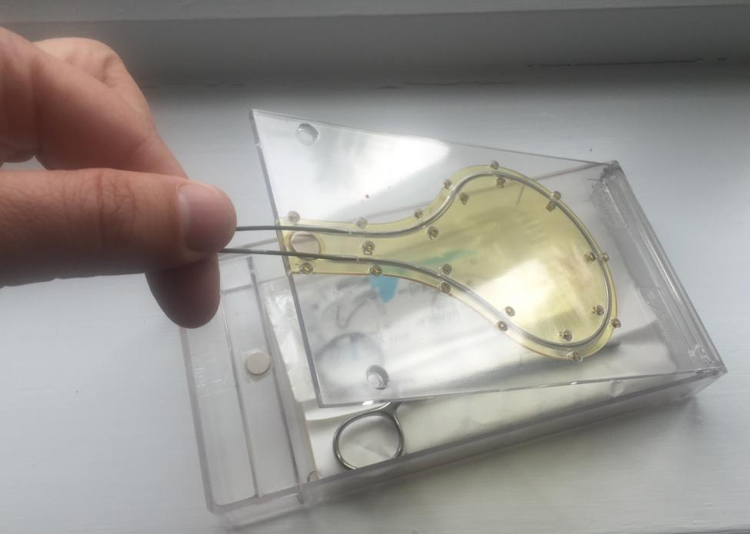
“When you make an error like this, it stays with you and affects you in so many ways. You can’t believe that you’ve been responsible for harming a patient and it makes you doubt yourself as a doctor. I’m glad that the solution has finally been developed”
WireSafe

Innovation Exchange
Clinicians Comments
Connected Health Cities
“I know of doctors who have forgotten to remove the guidewire. As far as I can see the WireSafe makes this error all but impossible, protecting both staff and patients”

“I like the way that it turns into a sharps box and allows easy cleaning up at the end. It actually makes the whole procedure easier”

“It makes procedures safer for the patient, and safer and easier for me”

“I’ve used the WireSafe previously in a trial….had we been continuing to use the WireSafe, I would have put all of the sharps inside the WireSafe, rather than having to carry them to the sharps bin. I’m sure I would not have had this injury if we were continuing to use the WireSafe” Foundation Training Doctor, following a sharps injury

